Static Culling base

StaticCulling is a module that allows preprocessing the visibility of objects, and then simply turning them on and off during runtime. This approach offers deep customization options and generates less load during runtime compared to Dynamic Culling. It's suitable for small and medium scenes, but not recommended for very large ones due to higher memory requirements compared to Dynamic Culling.
The StaticCulling solution involves dividing the scene's space into three-dimensional cells. Then, it calculates which objects are visible from each cell, and the data about these visible objects are recorded and stored.

- First, create a StaticCullingController. To do this, go to 'Tools -> NGSTools -> Advanced Culling System -> Static'.
- Object Selection. Open the window by clicking "Open Selection Tool" and add the objects you want to cull, following the prompts in this window.
- Scene Partitioning. Partition the objects in the scene into cells. In order to speed up the processing of the scene, the visibility of a cell is determined first, and then the visibility of objects in that cell. You need to strike a balance between the number of cells and the number of objects in that cell. Try to have up to ten to twenty objects in a cell, but do not select a Partition value that is too large. An example is shown in the picture below

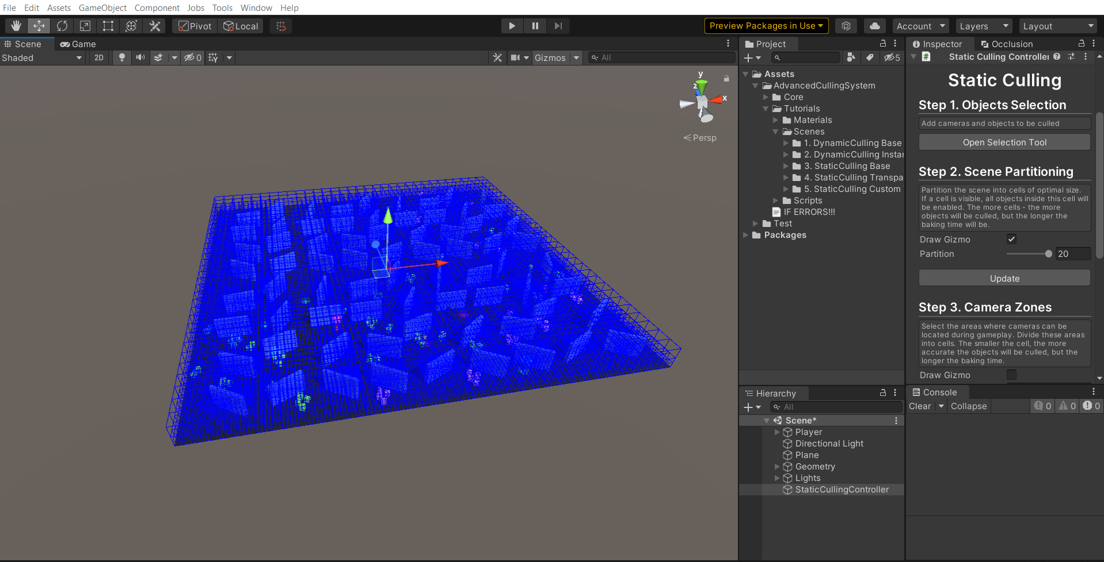
Too big “Partition” value

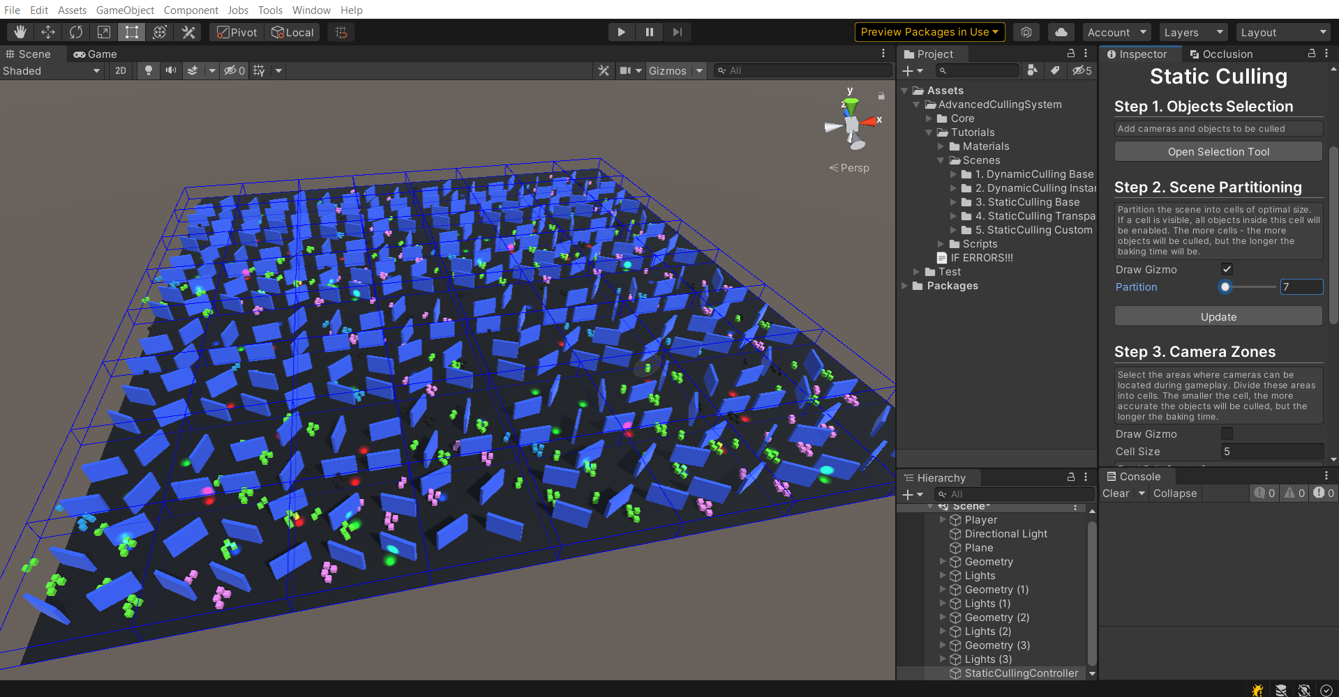
Not enough “Partition” value

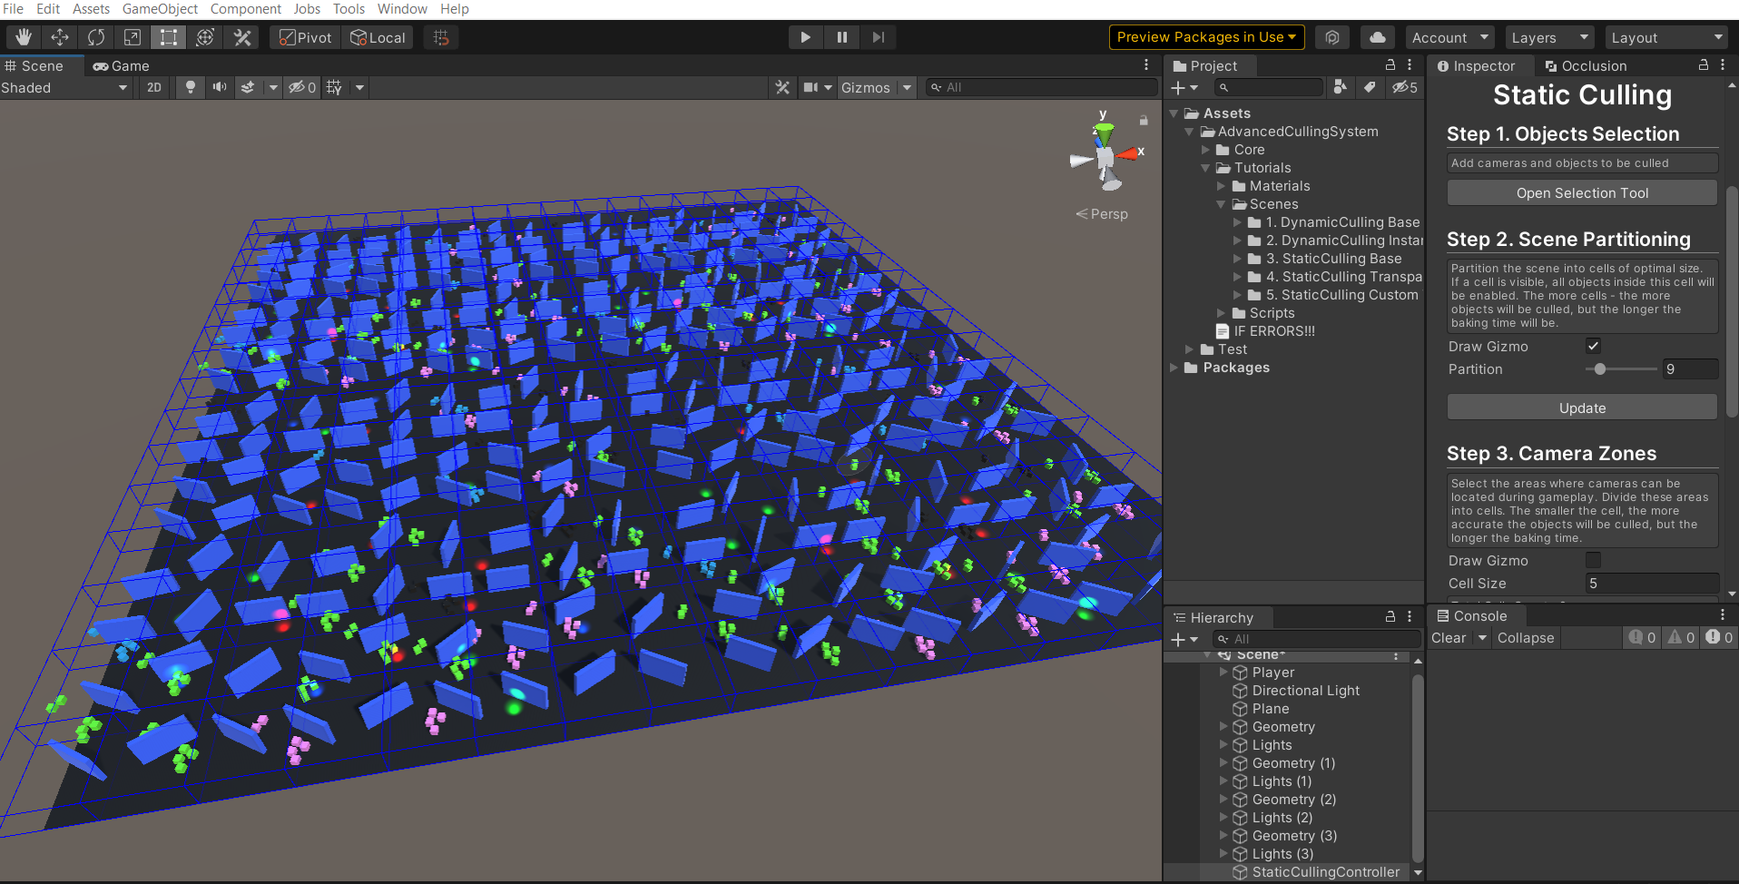
Optimal value

- Camera Zones. Specify the areas where the camera can be located during gameplay. The more precisely you specify these zones, the less memory will be used to store information about visible objects.
Select the optimal Cell Size. All Camera Zones will be divided into cells of the size you specify. Bake will determine which objects are visible from each cell, then this data will be saved and used in runtime. The smaller Cell Size you choose - the more objects will be culled, but the more memory will be used.
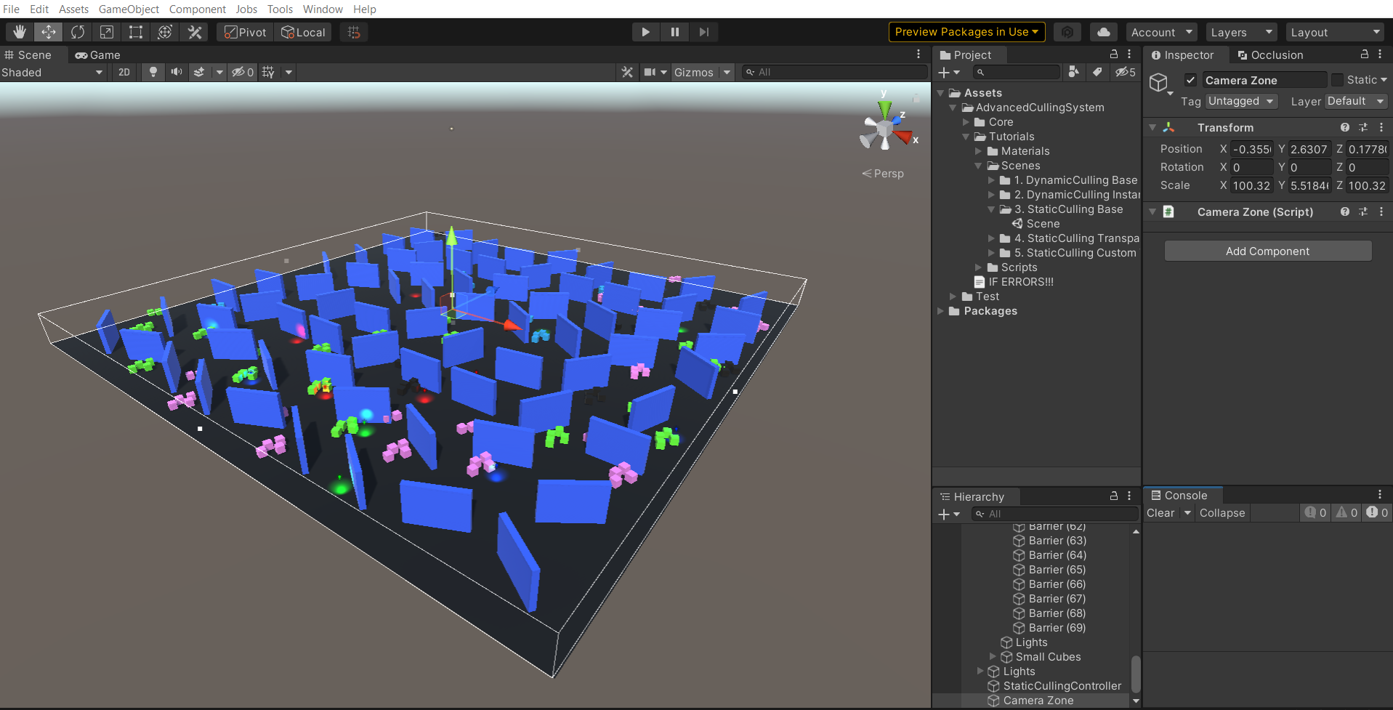
Optimal CameraZone

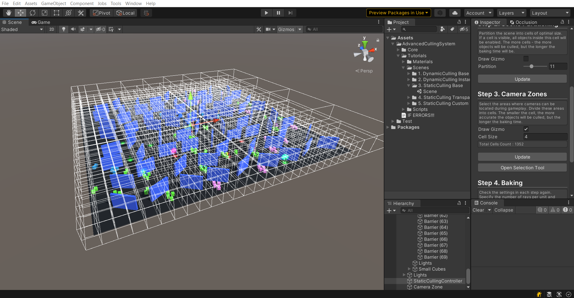
CameraZone divided into cells

- Baking. Specify the RaysPerUnit value. The larger the value, the more accurate the visibility of objects will be determined, but the longer preprocessing will take.
- StaticCullingCamera. Cameras that will participate in object culling must have a "StaticCullingCamera" component. If you specified these cameras in Step1, the component will be attached to them automatically.
Turn on DrawCells to see which cells are now affecting the camera.
Increase the tolerance value - if you want to take information from more cells near the camera. The more tolerance - the less artifacts, but the more visible objects.

- StaticCullingSource. The objects you select in Step 1 will automatically have the StaticCullingSource component attached to them. Make changes to this component to control the baking and culling process.

